Exploratory Data Analysis Report

Project: Premier League Home Advantage & Match Outcome Analysis
Dataset: English Premier League Match Results — 2021–22, 2022–23, 2023–24
Matches Analysed: 1,140 (380 per season × 3 seasons)
Tool: Python — pandas, matplotlib, seaborn

Introduction
The goal of this EDA is to investigate whether home advantage is statistically real in the post-COVID Premier League, and to figure out which match statistics actually explain why home teams do better. Going in, my hypothesis was straightforward: home teams win more often, and shots on target probably explains most of it. The EDA is how I tested that — and in a couple of places the data surprised me.
The analysis follows the four EDA steps from the assignment: selecting columns of interest, exploring individual columns, plotting two-dimensional relationships, and analysing correlations. Not every chart I made ended up being useful, and I have noted those moments too since finding nothing is still a finding.

Step 1: Selecting Columns of Interest
After loading and merging all three season files into a single 1,140-row dataset, the first job was deciding which of the 107 available columns were actually relevant. The majority — 82 of them — are betting odds from various bookmakers. I dropped all of those. They are not in scope for this project, and including them would just add noise to any correlation analysis.
That left 22 columns to work with, which I grouped into three types:
- 16 numerical columns: goals (FTHG, FTAG), shots (HS, AS), shots on target (HST, AST), fouls (HF, AF), corners (HC, AC), yellow cards (HY, AY), red cards (HR, AR)
- 5 categorical columns: full-time result (FTR), half-time result (HTR), HomeTeam, AwayTeam, Season
- 1 datetime column: Date

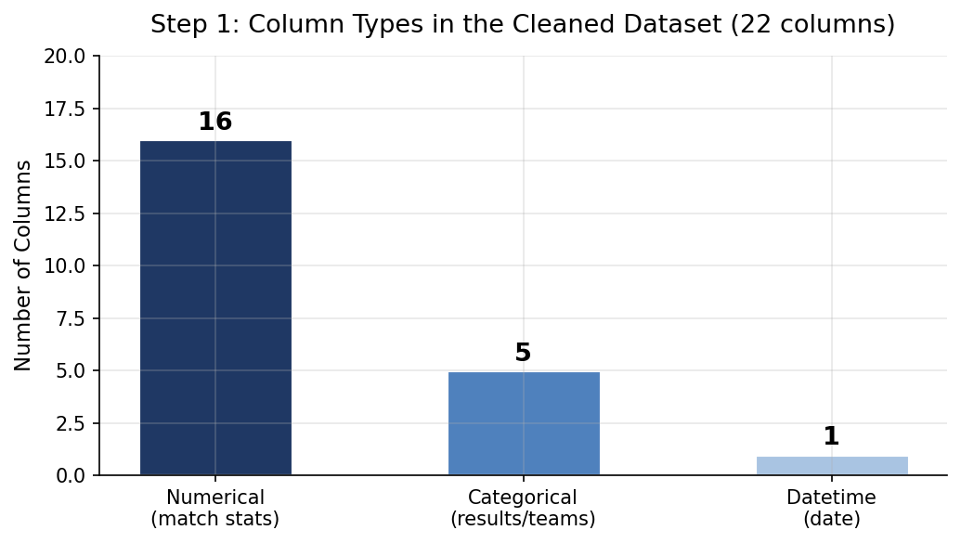
Figure 1: Breakdown of the 22 analytical columns by data type after dropping 85 betting odds columns
Takeaway: The dataset is dominated by numerical match statistics, which is good for correlation analysis. The one datetime column (Date) is useful for checking seasonality and monthly trends. FTR is the target variable — everything else is an independent variable I will test against it.

The key target variable is FTR (full-time result). The main independent variables I expected to matter most going in were HST (home shots on target) and AST (away shots on target), since these are the closest statistical proxy to actually threatening the goal. Fouls, corners, and cards I was less sure about — the EDA is partly about finding out whether they matter at all.

Step 2: Exploring Individual Columns

2.1 Null Values
I checked every column for missing values before doing anything else. The result was clean: all 22 selected columns have zero null values across all three seasons. The nulls that do exist in the raw files (1,183 total) are all in the betting odds columns that I excluded. This meant no decisions needed to be made about imputation or row removal.

2.2 Numerical Column Distributions
The histograms below show the shape of six key numerical columns. These one-dimensional distributions give a sense of how spread out the data is and whether any values look unusual.

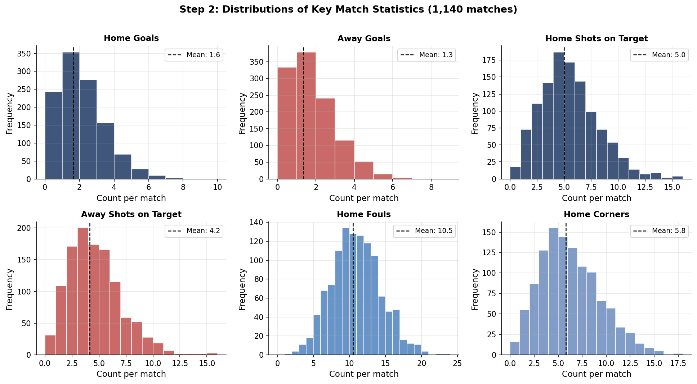
Figure 2: Frequency distributions for home/away goals, shots on target, fouls, and corners. Dashed lines show the mean.
Takeaway: Goals (home and away) follow a right-skewed distribution — most matches have 0–2 goals, and high-scoring games are rare. Shots on target also skew right, though less sharply. Home teams consistently average higher than away teams across goals (1.65 vs 1.33) and SOT (5.01 vs 4.16). Fouls and corners are roughly bell-shaped around their means. No distributions show anything alarming like impossible values or extreme outliers that would need removing.

2.3 Summary Statistics Table

Statistic | Home Goals | Away Goals | Home SOT | Away SOT | Home Shots | Away Shots | Home Fouls | Home Corners
Mean | 1.65 | 1.33 | 5.01 | 4.16 | 14.40 | 11.74 | 10.47 | 5.79
Median | 1 | 1 | 5 | 4 | 14 | 11 | 10 | 6
Std Dev | 1.38 | 1.24 | 2.68 | 2.46 | 5.89 | 5.26 | 3.52 | 3.12
Min | 0 | 0 | 0 | 0 | 1 | 1 | 1 | 0
Max | 9 | 8 | 15 | 15 | 36 | 31 | 23 | 17

Takeaway: Across every attacking metric — goals, shots, shots on target, corners — home teams average higher than away teams. The only metric where they are nearly equal is fouls (10.47 home vs 10.81 away), which is the first hint that fouls may not be a useful predictor of the result. The maximum of 9 home goals is Liverpool vs Bournemouth (Aug 2022) and the 8 away goals is Newcastle at Sheffield United (Sep 2023) — both verified as real results.

2.4 Categorical Column Breakdown
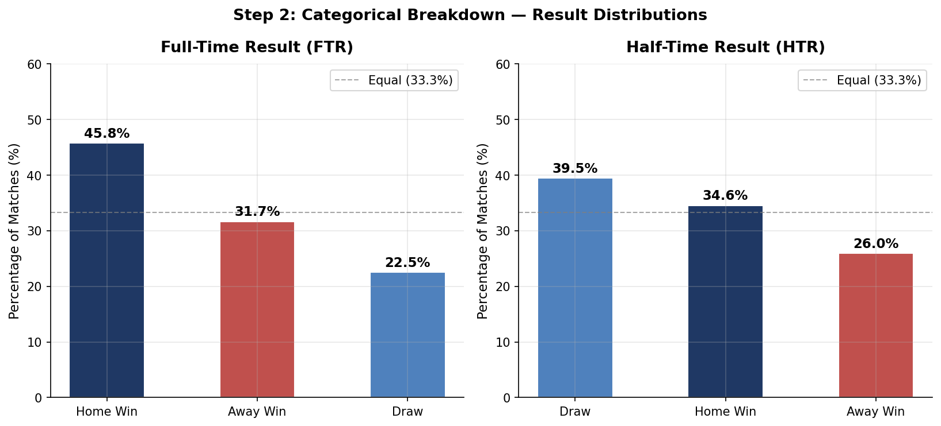
Figure 3: Percentage breakdown of full-time results (FTR) and half-time results (HTR). The dashed line shows 33.3% — what equal probabilities would look like.
Takeaway: This is the core finding of the EDA in one chart. Home teams win 45.8% of matches — almost 13 points above the equal-probability line. Away teams win just 31.7%. The half-time result (HTR) shows a similar pattern: home teams lead at half-time 41.5% of the time. Both distributions confirm that the home-side advantage appears well before full time.

2.5 Datetime Exploration — Monthly Goal Trends
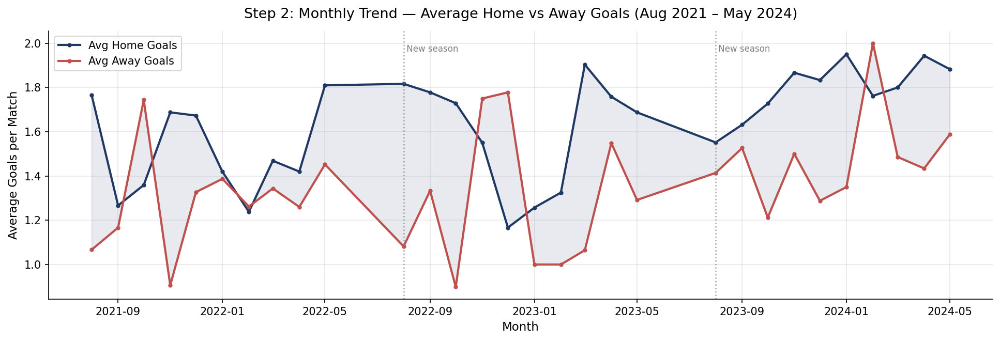
Figure 4: Average home and away goals per match by month, August 2021 to May 2024. Dotted lines mark the start of new seasons.
Takeaway: I was looking to see whether home advantage in terms of goals varies by time of year — for example, whether home teams do better early in the season when away sides are unfamiliar with new players. The chart does not show a strong seasonal pattern. The home-over-away gap in goals is fairly consistent throughout each season. There is some month-to-month noise (small sample sizes per month), but nothing that suggests seasonality is a major factor. This was a chart that did not end up supporting any strong hypothesis, which is fine — it rules out one possible explanation for home advantage.

Step 3: Two-Dimensional Analysis

3.1 Match Outcomes by Season
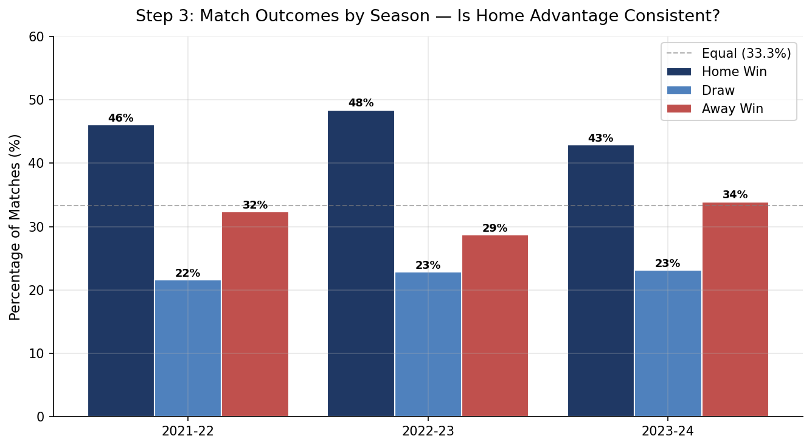
Figure 5: Home win, draw, and away win percentages broken down by each of the three seasons analysed.
Takeaway: Home advantage is consistent across all three seasons. The home win rate ranges from 42.9% (2023–24) to 48.4% (2022–23), but even in the weakest year it is still well above 33.3%. The pattern does not appear to be driven by one unusual season — it is structural. Interestingly, 2023–24 had the highest away win rate (33.9%) of the three years, which might reflect tactical evolution towards more aggressive away strategies, but that is speculative at this point.

3.2 Home Goals vs Away Goals by Result
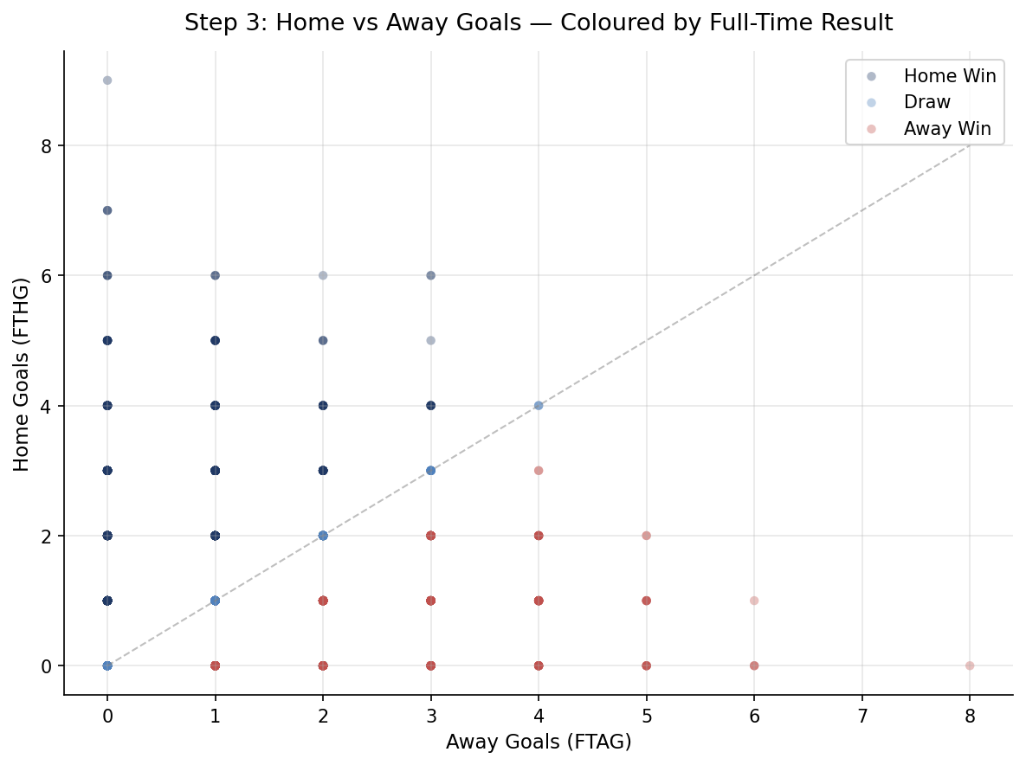
Figure 6: Scatter plot of home goals (y-axis) vs away goals (x-axis), coloured by full-time result. The dashed line shows where home and away goals are equal.
Takeaway: The scatter plot confirms the obvious but makes it visual: home wins (navy) cluster above the diagonal, away wins (red) below it, and draws sit on or near it. What is more interesting is the spread — there are matches with 3–4 away goals that still ended in a draw or home win, and vice versa. The plot also shows that low-scoring games (0–0, 1–0, 0–1) are the most common, which matches the histogram findings. No major surprises here, but it confirms the result-coding and the data integrity.

3.3 Shots on Target by Match Result
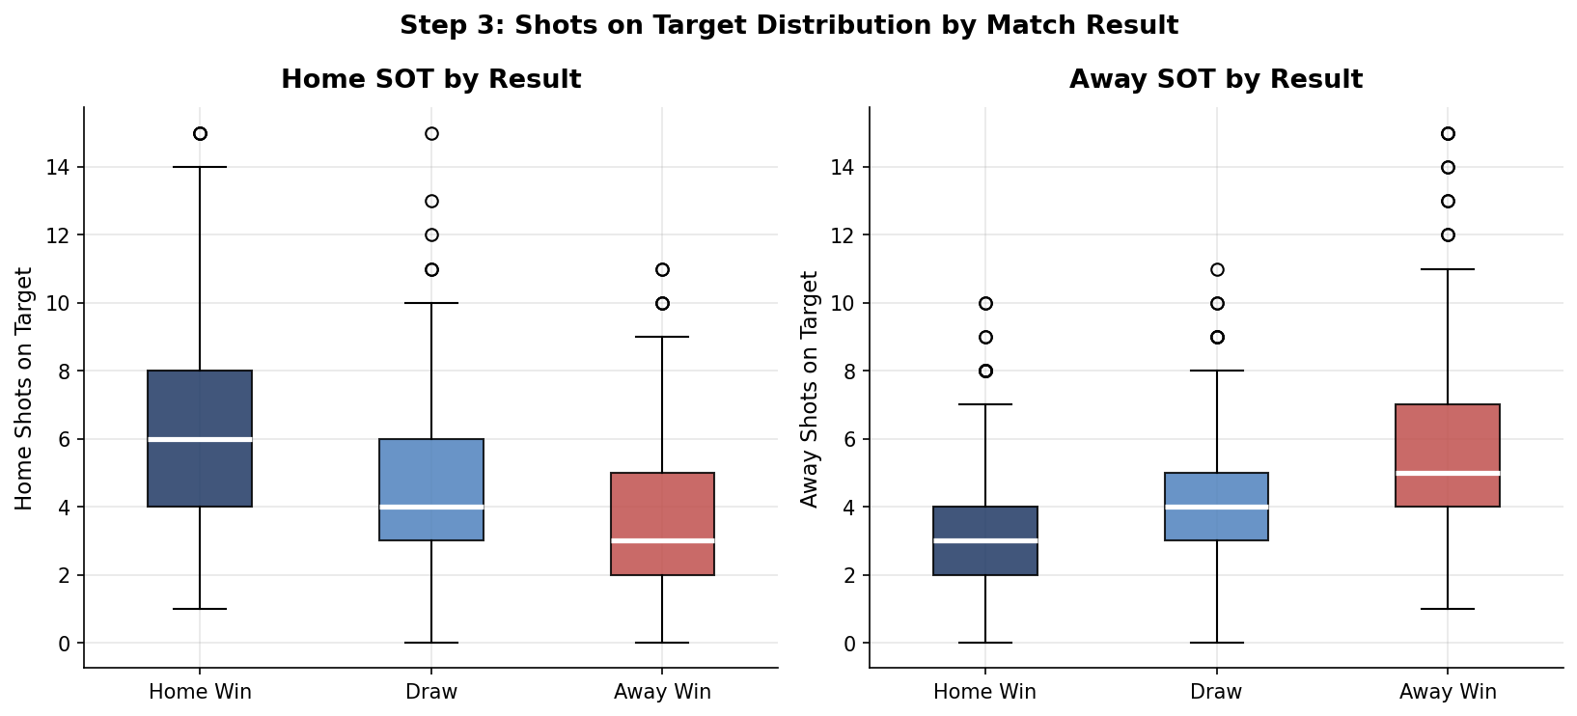
Figure 7: Boxplot of home and away shots on target, split by full-time result (home win / draw / away win).
Takeaway: This is one of the most informative charts in the EDA. The left panel shows that home teams who win matches average notably higher home SOT, and the right panel shows that when away teams win, they tend to generate more shots on target than the home side. The boxes are well-separated across the three result categories for both panels, which is a strong visual signal that SOT is discriminating between results. This is consistent with the correlation analysis in Step 4.

3.4 A Chart That Found Nothing: Fouls vs Result
I also investigated whether the number of fouls committed by the home or away team varied meaningfully by result. My expectation was that losing teams might foul more (desperation fouls when chasing a game), which would mean high away fouls might predict home wins.
When I plotted the average fouls by result, the differences were very small — home teams foul about the same amount regardless of whether they win, draw, or lose. Away teams show a slight tendency to foul a bit more in losses, but the difference is barely noticeable. I chose not to include that chart because it does not tell a useful story. But the finding itself is still worth noting: fouls do not appear to be a meaningful predictor of Premier League results.

Step 4: Correlation Analysis

4.1 Full Correlation Heatmap
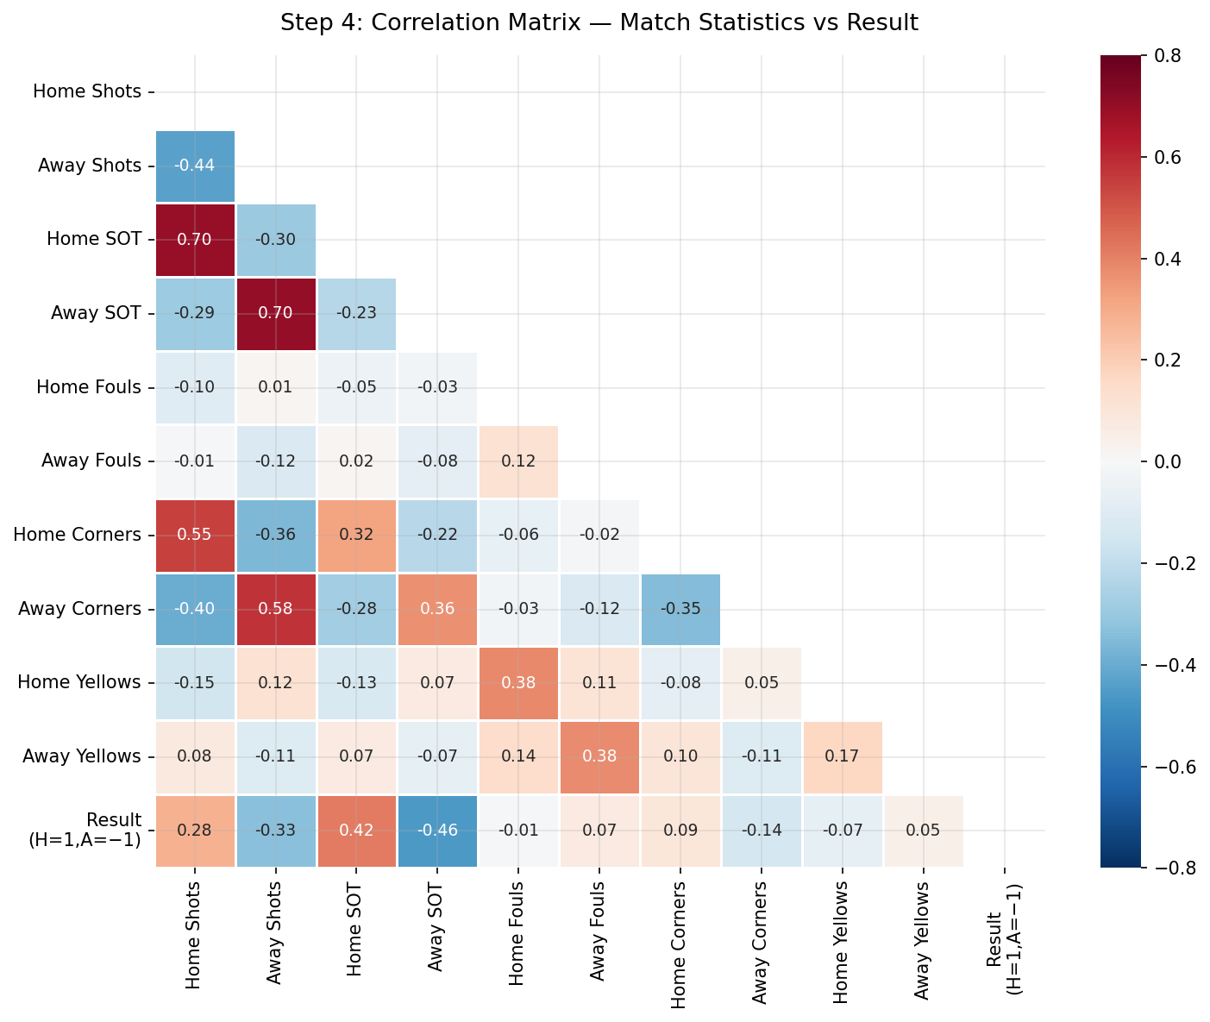
Figure 8: Pearson correlation matrix for all selected match statistics and the encoded result variable (H=1, D=0, A=−1). Lower triangle only.
Takeaway: The heatmap confirms the hierarchy of predictive power. The strongest correlations with the result are shots on target (home and away). Home and away shots (total) are also moderately correlated with each other, which makes sense — open, attacking games produce more shots for both sides. Fouls and cards show very weak correlations with the result, near zero. One slightly surprising finding: home corners (HC) and away corners (AC) have a stronger relationship with their respective shot counts than with the result directly, which suggests corners are more a consequence of attacking play than a cause of winning.

4.2 Ranked Correlations with Result
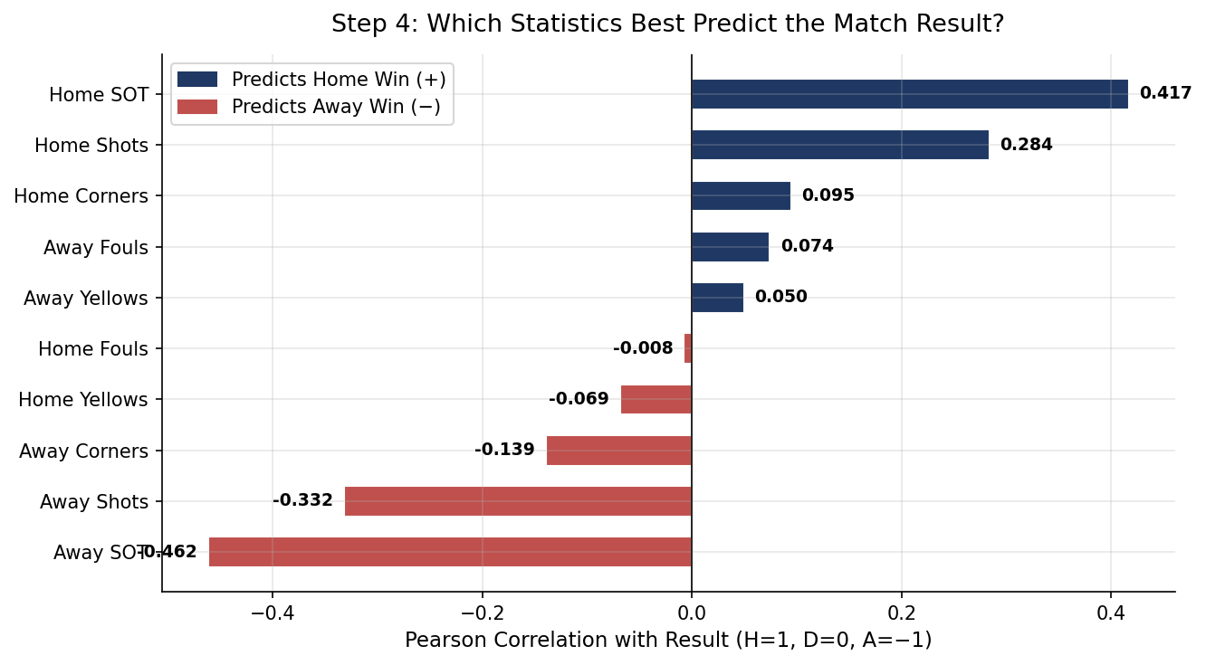
Figure 9: Pearson correlation of each match statistic with the result (H=1, D=0, A=−1). Navy = predicts home win, red = predicts away win.

Variable | r (correlation) | Direction | Interpretation
Away SOT (AST) | −0.463 | Away wins | Strongest predictor overall — away teams generating SOT strongly predicts away wins
Home SOT (HST) | +0.420 | Home wins | Second strongest — home SOT is the best single predictor of home wins
Away Shots (AS) | −0.267 | Away wins | Moderate — total shots matter but less than on-target shots
Home Shots (HS) | +0.225 | Home wins | Moderate positive relationship
Away Corners (AC) | −0.141 | Away wins | Weak — corners reflect attacking pressure but not strongly predictive
Home Corners (HC) | +0.091 | Home wins | Very weak positive relationship
Away Yellows (AY) | −0.074 | Away wins | Near zero — not meaningful
Home Fouls (HF) | −0.012 | Slight away | Effectively zero — fouls do not predict results
Away Fouls (AF) | +0.071 | Slight home | Very weak — not meaningfully predictive

Takeaway: The correlation analysis clearly separates the predictive statistics from the noise. Shots on target (both home and away) are by far the strongest predictors of match results. Total shots matter too but less so — suggesting that shot quality (accuracy) matters more than shot volume. Fouls and yellow cards are essentially uncorrelated with the result, which settles the question I had going in. Corners sit in the middle — weakly associated with results, probably because they are a downstream effect of attacking pressure rather than a cause of winning.

4.3 Additional Finding: Home Win Rate by Team
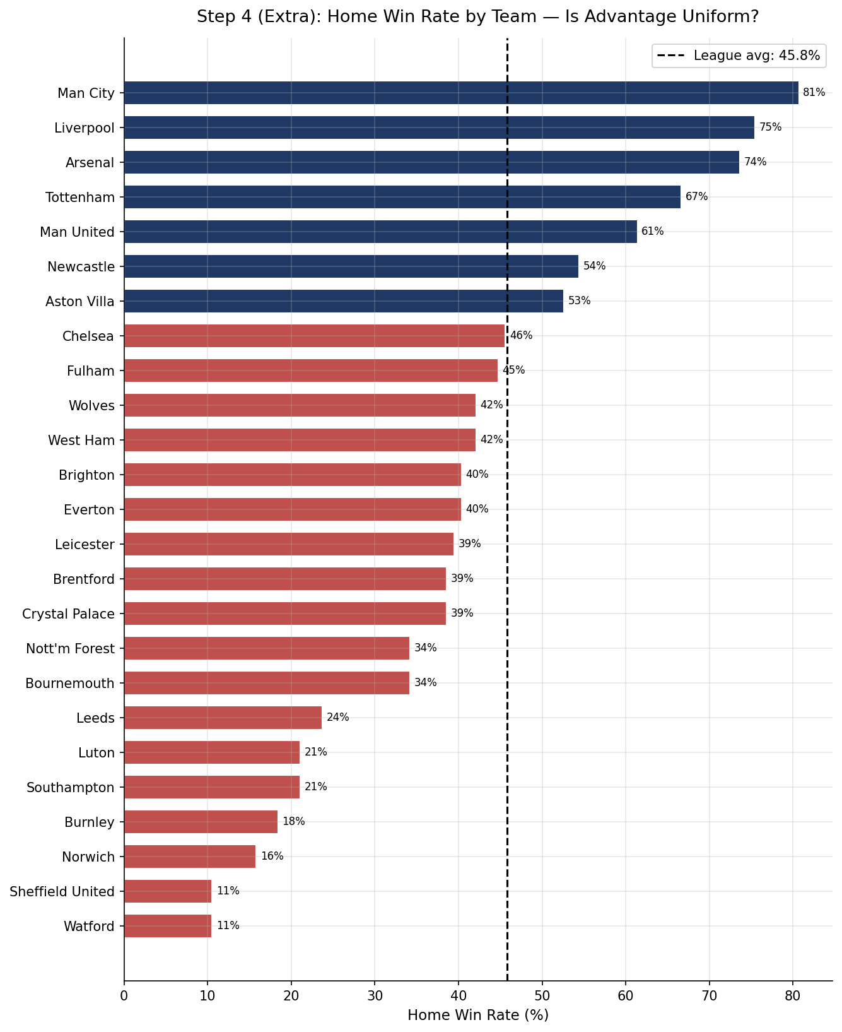
Figure 10: Home win rate for each team present in the dataset (2021–24). The dashed line shows the overall league average (45.8%).
Takeaway: This chart was not part of my original plan but came out of a question that emerged during the EDA: is home advantage spread evenly, or do certain clubs benefit far more than others? The answer is striking. Manchester City win over 80% of home games. Liverpool and Arsenal are above 73%. At the other end, Sheffield United, Watford, and Norwich win fewer than 20% at home — barely better than the away average. This suggests that what we call ‘home advantage’ at the league level is partly driven by elite clubs dominating their home fixtures. For weaker clubs, playing at home provides much less of a boost.

Key Findings & Sub-Questions Uncovered

What the EDA Confirmed
- Home advantage is real and statistically significant. Home teams win 45.8% of matches vs 31.7% for away teams — a 14-point gap that holds across all three seasons.
- Shots on target is the strongest measurable predictor of match results. Away SOT (r = −0.46) and home SOT (r = +0.42) dominate all other variables.
- Fouls are not a meaningful predictor. The near-zero correlation (r = −0.01 for home fouls) was the most surprising finding — I expected at least a weak relationship.
- Home advantage is consistent across seasons but not across clubs. It has held steady in 2021–22, 2022–23, and 2023–24, but the strength of the effect varies enormously between elite and weaker clubs.

Sub-Questions This Has Opened Up
- Why do elite clubs benefit so much more from home advantage than lower-table sides? Is it squad depth, crowd intensity, better facilities, or simply the fact that they are better teams who would win most games anyway?
- Does the half-time result predict the full-time result, and is this stronger for home teams? (Initial check shows home teams leading at HT win 78.2% of those games — worth exploring further.)
- Could a simple model (e.g. logistic regression) using SOT and a few other statistics predict the result with meaningful accuracy? The correlation analysis suggests it might be worth trying.
- Is the slightly weaker home advantage in 2023–24 the start of a trend, or just normal variation? A longer dataset would help answer this.

Data source: football-data.co.uk — Seasons 2021–22, 2022–23, 2023–24. All data is publicly available and free to use for educational purposes.

